Isopropyl alcohol spray 99%: Best alcohol spray to stay safe in 2020

Isn't it the highest of all high times when we need to be extra cautious against germs? It's possible to be safe when you are inside the home, but who keeps a record of what your hand touches once you step outside? It's impossible to remember every single thing your hand accidentally comes across. The least and undeniably, the best thing you can do for this problem is to get a hand sanitizer. Trust me; you don't want to compromise on this.

Here's what we recommend to help you fight through germs and virus safely-

Isopropyl alcohol spray 99%
You might have heard of it the first time now, because it is manufactured considering all the sanitizers that didn't work out! In other words, it's aware of what works and what content's effective to kill the virus. This alcohol spray from Flalab, a company located in Miami, is the best available in the market as it gives high priority to the safety.

What makes Isopropyl alcohol spray 99% best?
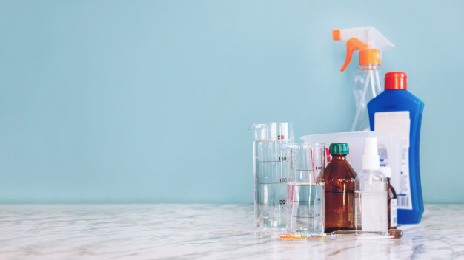
Its effective isopropyl alcohol solution claims to kill the virus within seconds of application. We understand what a hassle it could be if you are traveling in public transport and need to wash your hands; therefore, it is travel friendly! Isopropyl alcohol spray 99% has a unique compact design that fits in the minimum space possible.

Not just the traveling part, you can use it almost everywhere you need to tough. When you are in the supermarket and want to grab the shopping cart, but can't cause everyone else touched it too, you can use this spray!

When you're driving, you can spray it on the steering wheel. Not to mention everyone loves going to the park no matter what the age is. Especially if you have a child, you need to pay extra attention to the swings. You can spray it on the swing rod and make it safe for your child and everyone else!

There's no need even to mention the amount of bacteria/virus fight their way to reach out to mobile screens. We use our mobile most of the time in a day. It won't hurt to spray it once or twice just to stay safe! The solution is mobile friendly and doesn't harm the internal. As you see, anyone can use it, including doctors, lab technicians, or even a traveling student! There's no question of comprising hygiene, whether it is a commercial industry or personal use.

Where to buy?
Flalab is the best and most trustable brand in Miami when it's about hygiene. Working effectively as an accomplished chemical company, we assure you of the quality of every product. We aim to follow quality control and fulfill the claims that our product makes! Don't hesitate or give a second thought to purchase this isopropyl alcohol spray 99%.

Is disinfectant necessary?
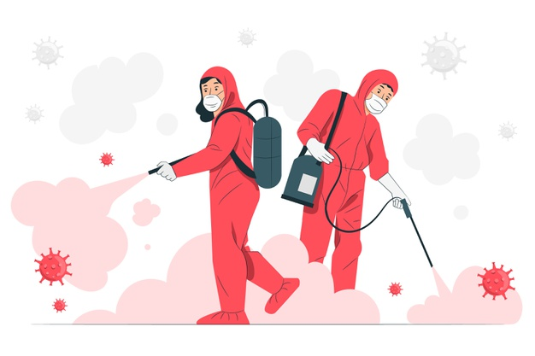
Some bacteria’s can be hard to kill, including spores, microbes, and even viruses. The active formula of an essential disinfectant is classified into unique names and categories that make it purposeful for various uses. You need to understand the pros and cons of the sanitizers and disinfectants to distinguish the chemical formulation and usage.

Keep reading the information below to understand the proper uses of these disinfectants to reduce health hazards. An appropriate disinfectant should be able to remove microbes and pathogens by targeting them specifically and adequately.

Isopropyl alcohol 99% spray is widely used on any surface microbes can live on. You can literally use it everywhere to keep your things germ free, whether at home or in a public place. It can be used for generic services or on instruments as well. The most significant amount of usage is still in the industrial and commercial sectors.

Additional cleaning before isopropyl alcohol 99%- required or not?
Sanitizing everything you touch has recently become a vital part of our everyday lifestyle. We cannot risk falling in the hands of viruses. The most preferred task of any decontamination strategy is cleaning.

According to the MN department of health, before disinfecting, all the surfaces need to be thoroughly cleaned. Sanitizing efforts can sometimes fall short and prove less useful because of protective layers from biofilms and grit. Cleaning one can remove non-visible and visible soil and microbes, including protozoa, bacteria, and viruses, from any surface.
Microbes in the form of pathogens can still lead to sickness in humans. It is vital to the clean ahead of putting a disinfectant by mopping, scrubbing or wiping- include a general cleanser like soap.

Detergent is, however, not as effective as this isopropyl alcohol 99% spray. It may have the lipophilic and hydrophilic parts with non-Ionic, cationic, amphoteric, and anionic groups; it doesn't have the unique formulation you can only find a disinfectant. Just by using the physical mechanics and limited activity, one can lower the proliferation of bacteria spread through cleaning.

One may use tacky rollers for an effective removal of contamination. Other options include antimicrobial soaps that contain alcohol, iodine, chlorine, quaternary ammonium compounds. However, when compared none of these are as effective as the isopropyl alcohol spray 99%.

This non-gel sanitizer spray will keep the surface free from bacteria. Cleaning is essential, but it's not all that can kill germs.

Unlike other disinfectants, which have to go through a two-step cleaning method to thoroughly remove the bacteria, with isopropyl alcohol 99%, you won't need to worry about that.

Due to its exceptional qualities of killing germs, it has widespread in the manufacturing industries. Mostly it is gaining popularity in the clinical sector in Miami. One wipe of this disinfectant and you won't need to be scared of getting an attack of the most deadly bacteria’s!

Why is isopropyl alcohol 99% a better choice?
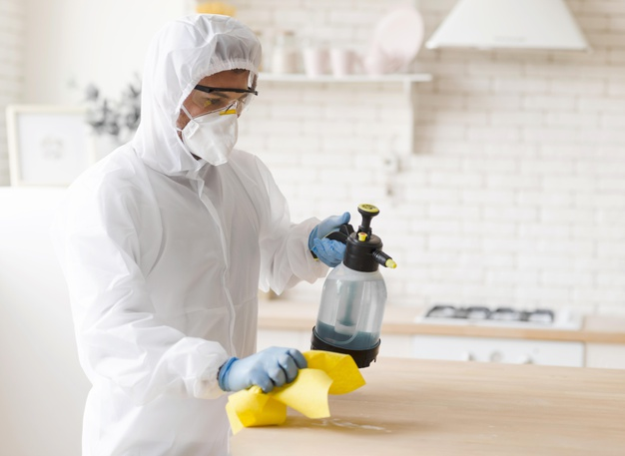
While there are lots of disinfectants and hand sanitizers in the market to attract your attention, here is why this is the most suitable choice among all.

An ordinary disinfectant would kill germs to some percentage present on the surface. By doing so, it may stop the spread of infection to some extent. Whereas isopropyl alcohol 99% makes sure to remove more than 90% of bacteria’s on the surface, an object or any surface.

It inactivates the function of bacteria, viruses, and fungi so that their reaction is irreversible. It even manages to kill the bacterial spores present in the environment.

This alcohol sanitizer, when used by public health requirements, reduces the number of germs on the objects and the surface up to the level of optimum safety. One can either disinfect or clean the item further for lowering the spread risk.

Isopropyl alcohol 99% spray can lower the bacteria population to a significant amount in the inanimate environment in Miami.

Where can you use isopropyl alcohol 99%?
Is this the first time you hear about isopropyl alcohol? The solvent-based rubbing alcohol is a dream cleaner. It has endless uses for households as well as the commercial industry. Here are the top 5 reasons why you should use isopropyl alcohol sanitizer in household-

Antibacterial cleaning agent
Anything from bacteria, viruses, or even fungus can be killed using isopropyl alcohol. You can disinfect medicinal objects too, which is a commonplace to spread illness. You can just have one spray to clean your household objects that are prone to get attacked by bacteria- making it the best choice as an antibacterial agent.

Cleaner for stainless steel
It is the best cleaner to remove fingerprint traces within a wipe! The steel surface will get a streak-free finish because of the high evaporation rate. Not just the germ-free, you will get a shiny and new look on any surface by using isopropyl alcohol. It will evaporate in no time, leaving zero smudges.

A window cleaner
In just a spray, and you can clean your windows as good as new, looking streak-free. It will show quick results as good as the stainless steel leaving no streaks.

Mould remover
We all have blinds in our house because it is an excellent spot for bacterias and germs to grow. You can use this isopropyl alcohol 99% to remove the sticky residue with a texture like chewing gum from the skin and material surfaces. If you want to remove mould from any rugged surface, isopropyl alcohol 99% is the way to go.

Rubbing alcohol
To kill the bacteria thriving on your skin, you need a safe disinfectant. Isopropyl alcohol solution is safely diluted to the extent that it doesn't harm the skin by giving a tingling sensation.

These are just some of the many uses of isopropyl alcohol for household purposes. Let's take a look at how it's making our commercial sector happy by doing wonders-

Uses in the commercial sector
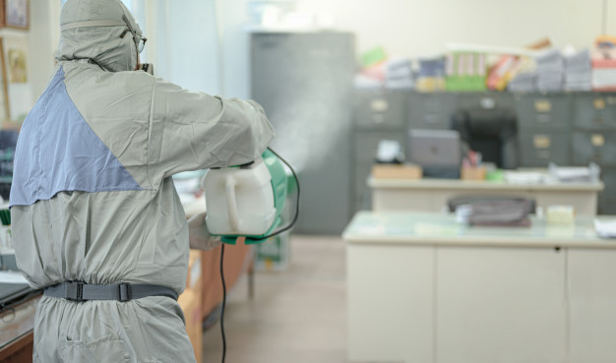
The purest form of all, the isopropyl alcohol 99%, is best to use when less or minimum concentration proves to be ineffective. Some of the popular uses include cleaning electronics acting as a disinfectant, and removing fats and oils.

United States being the largest user of isopropyl alcohol has effectively excelled in wiping out bacteria by its help. Compared to the global growth rate, Africa, the Middle East, and Asia show slightly higher usage statistics as the consumption rates tremendously increased from the past few years.

Besides just a household cleaning ingredient, isopropyl alcohol is found in commercial products like paint thinner, Ink, and all-purpose cleaners. It's a significant component of a typical disinfectant that effectively kills viruses and bacteria, as it is the high purity grade solution.

Additional uses of 99% isopropyl alcohol

- The sole purpose of the solution is to clean surfaces, alone, and be a part of an all-purpose cleaner. A significant benefit you get is it is noncorrosive to plastics or metal, making it ideal for all kinds of surfaces. It doesn't leave a smear or smudge on reflective surfaces like a screen or glass.
- It hardly leads to any complications, unlike other disinfectants in the industrial sector. It evaporates quickly and leaves no stain; it can be hard to judge the surface just by looking if it is already cleaned or not. As water is a significant component of cleaning products, you must be aware of not spraying it on electronics. Here you can significantly benefit from isopropyl alcohol 99% as it doesn't spoil the internals of any gadgets and evaporates quickly. Both internal and external of the component will be left residue-free.
- Another usage is to prevent infection of minor wounds like a paper cut. It is extensively advantageous in the piercing and tattoo industry.
- It is widely used in pharmaceutical labs, medical locations, and hospitals for disinfection.
- Alcohol is the most popular disinfectant, but it won't work well if its contribution to a solution is below 50%. Therefore isopropyl alcohol 99% is adequate and equally suitable for lab grade and medical applications.
- It can also be used as paint strippers and is a component of inks and paint thinner.
- It is heavily preferred in the beauty industry to wipe the nails of a client before a manicure. On an alcohol cleaned nail, one can put polish, nail varnishes, or any accessory without harming the surrounding skin.

Advantages of isopropyl alcohol 99% spray
Other than its benefits of being a disinfectant, the main advantage is it cleans quickly and evaporates in no time. It leaves behind no residue of being ever used. It is an effective agent against grime, residue, or grease.
As a result of modern manufacturing, it is highly used in many industries.

This isopropyl alcohol 99% is made of superior grade, effective enough to expand in the marketing industry. It has given a new challenge to all the present disinfectants by its innovative solution and water sensitive application. With the progress in digitalization, it is a definite prediction of a rise in demand for isopropyl alcohol 99% in every household or industry.

Final words
Isopropyl alcohol spray 99% is undeniably the one hole you need to fill in your hygienic life, the one thing you should not miss out on. It's perfect to use it anywhere as there are innumerable places to left to disinfect. With its help, you can clean your hands at an instant without waiting too long.

